Pojo-Servlet-JSP-Hibernate flow:
Pojo is Model
JSP/Servlet – View
Servlet/JSP – Controller
Hibernate as DAO
Request/Response pojo pojo
DAO
Browser
HTML as view
DB
Controller

---------------------------------------------------1. User Registration------------------------------------------------------------
Browser

1.request
Index.jsp
DB
/register
10. response
2.GET
Register.jsp
success.jsp
9. Forward Success
Web.xml
3.POST
5. pojo
UserDao
Servlet mapping 8. success
hibernate.cfg.xml & pojo-hbm.xml/annotation
.
url-servlet 6.pojo Save 7. Success
Server
DB info &
mapping
pojo-table

Simple Hibernate Project
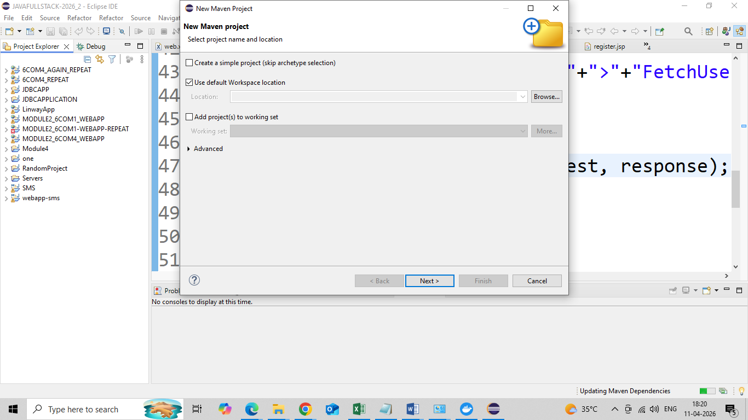
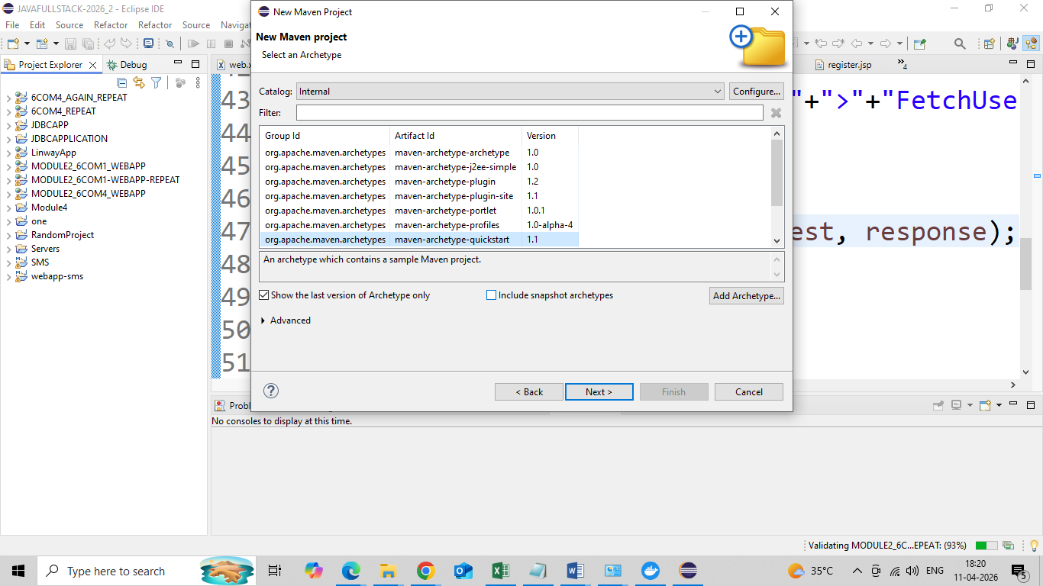

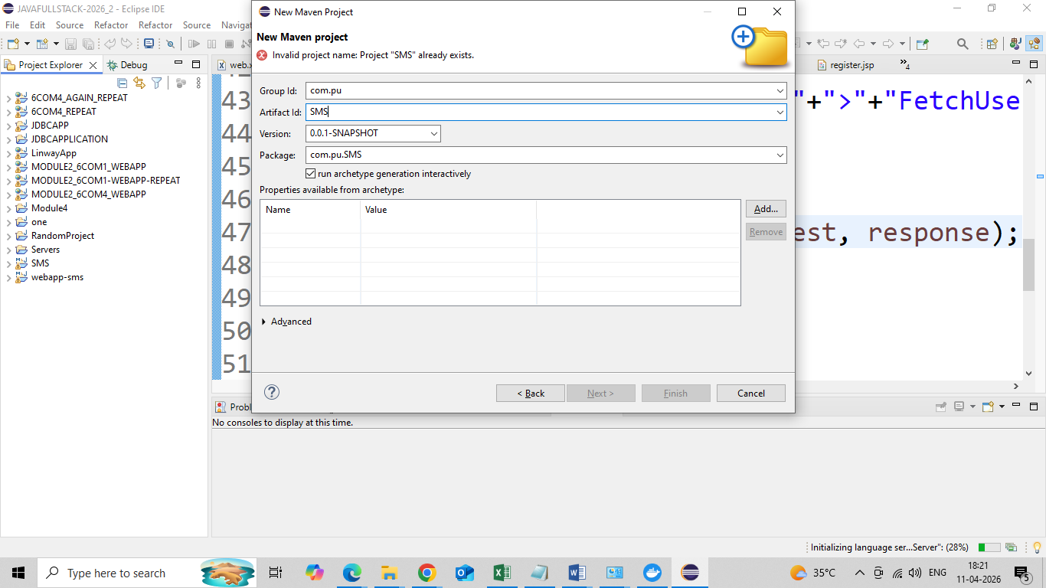
Hibernate with servlet and JSP
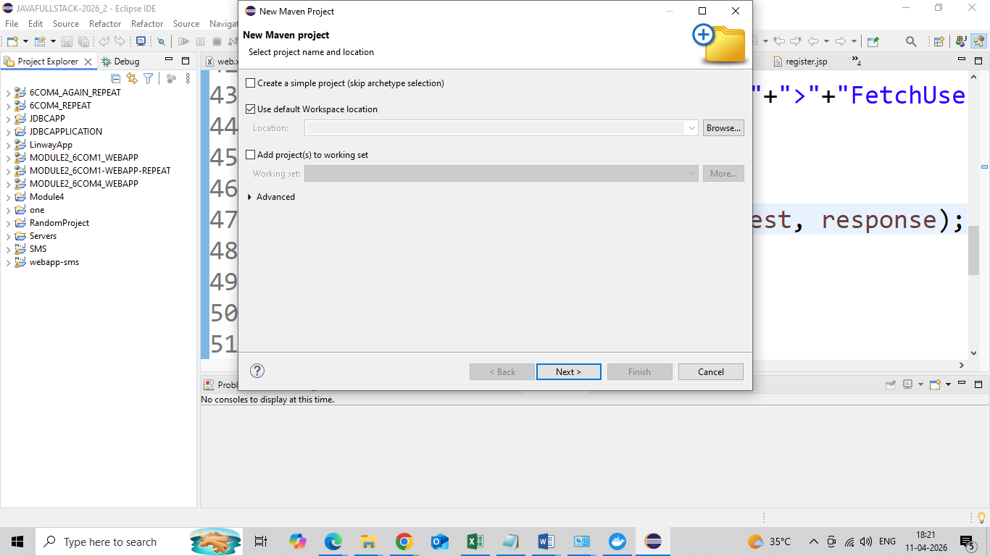

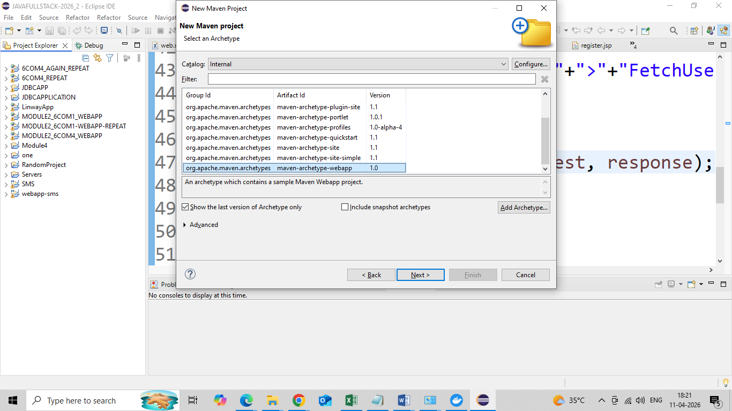

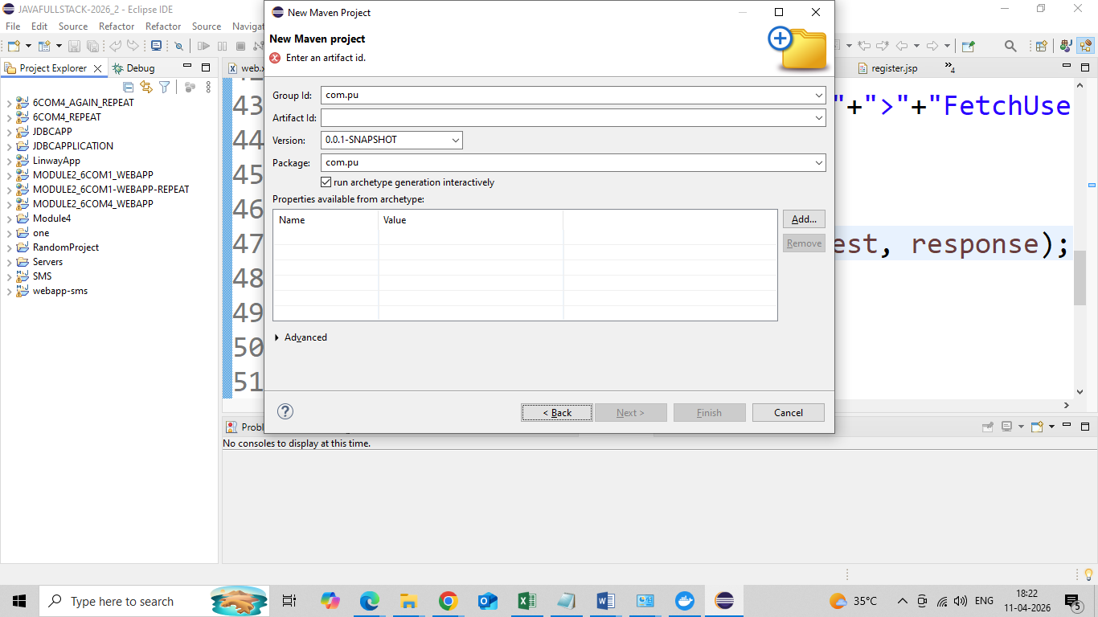

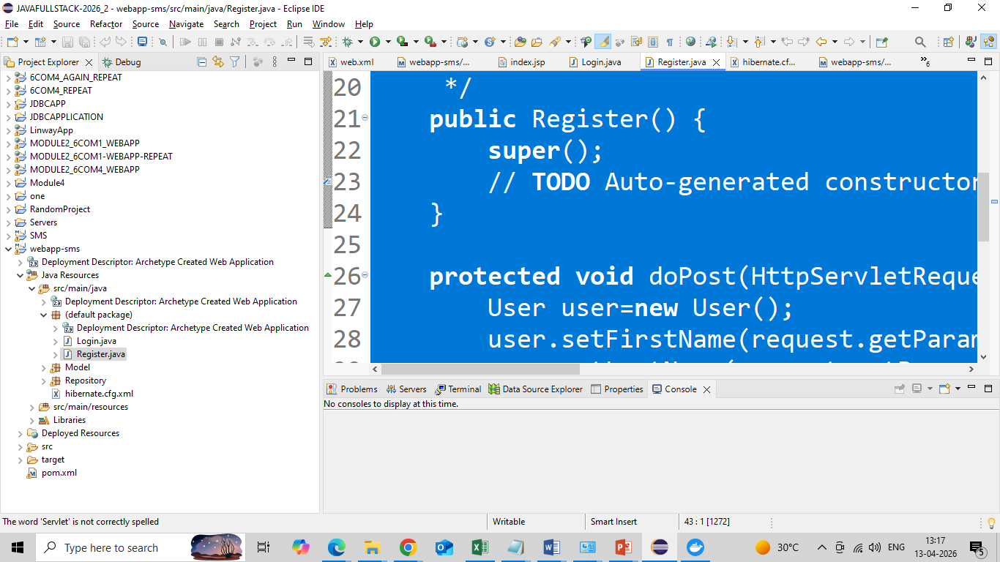
All jsp must be created under webapp folder (rightclick).

index.jsp

<html>
<body>
<center>
<h2>Hello User!</h2><br><br>
<h2>Home</h2>
<a href="register.jsp">Register Here</a>
</center>
</body>
</html>

register.jsp

<%@ page language="java" contentType="text/html; charset=ISO-8859-1"
pageEncoding="ISO-8859-1"%>
<!DOCTYPE html>
<html>
<head>
<meta charset="ISO-8859-1">
<title>Insert title here</title>
<link rel="stylesheet"
href="https://stackpath.bootstrapcdn.com/bootstrap/4.3.1/css/bootstrap.min.css"
integrity="sha384-ggOyR0iXCbMQv3Xipma34MD+dH/1fQ784/j6cY/iJTQUOhcWr7x9JvoRxT2MZw1T"
crossorigin="anonymous">

</head>
<body>
<div class="container">
<div class="row text-center" style="color: tomato;">
<h2>User Registration with JSP, Servlet and Hibernate</h2>
</div>
<hr>
<div class="row col-md-10 col-md-offset-3">

<div class="card card-body">

<h2>User Register Form</h2>
<div class="col-md-8 col-md-offset-3">

<form action="register" method="post">

<div class="form-group">
<label for="uname">First Name:</label> <input type="text"
class="form-control" id="uname" placeholder="First Name"
name="firstName" required>
</div>

<div class="form-group">
<label for="uname">Last Name:</label> <input type="text"
class="form-control" id="uname" placeholder="last Name"
name="lastName" required>
</div>

<div class="form-group">
<label for="uname">User Name:</label> <input type="text"
class="form-control" id="username" placeholder="User Name"
name="username" required>
</div>

<div class="form-group">
<label for="uname">
Password:</label> <input type="password"
class="form-control" id="password" placeholder="Password"
name="password" required>
</div>

<button type="submit" class="btn btn-primary">Submit</button>

</form>
</div>
</div>
</div>
</div>
</body>
</html>

success.jsp

<%@ page language="java" contentType="text/html; charset=UTF-8"
pageEncoding="UTF-8"%>
<!DOCTYPE html>
<html>
<head>
<meta charset="UTF-8">
<title>Insert title here</title>
</head>
<body>
<center>
<h2> User Added Successfully</h2>
</center>
</body>
</html>

Create two packages under src/main/java
Name them Model and Repository
All pojo must be created under Model package
package Model;
import java.io.Serializable;

import javax.persistence.Column;
import javax.persistence.Entity;
import javax.persistence.GeneratedValue;
import javax.persistence.GenerationType;
import javax.persistence.Id;

@Entity
public class User implements Serializable {

@Id
@GeneratedValue(strategy = GenerationType.AUTO)
private int id;

@Column
private String firstName;

@Column
private String lastName;

@Column
private String username;

@Column
private String password;

public String getFirstName() {
return firstName;
}
public void setFirstName(String firstName) {
this.firstName = firstName;
}
public String getLastName() {
return lastName;
}
public void setLastName(String lastName) {
this.lastName = lastName;
}
public String getUsername() {
return username;
}
public void setUsername(String username) {
this.username = username;
}
public String getPassword() {
return password;
}
public void setPassword(String password) {
this.password = password;
}
public User(int id, String firstName, String lastName, String username, String password) {
super();
this.id = id;
this.firstName = firstName;
this.lastName = lastName;
this.username = username;
this.password = password;
}
public User() {
super();
}

}

All DAO must be under Repository package
package Repository;
import java.util.List;

import org.hibernate.Session;
import org.hibernate.SessionFactory;
import org.hibernate.Transaction;
import org.hibernate.cfg.Configuration;

import Model.User;

public class UserDAO {
Configuration configuration=null;
SessionFactory sessionFactory=null;
Session session=null;
public UserDAO() {
//1. create Configuration object
configuration=new Configuration().configure().addAnnotatedClass(User.class);
//2. create Session Factory object
sessionFactory=configuration.buildSessionFactory();
//3. Create Session object
session=sessionFactory.openSession();
}
public void saveUser(User user) {
//4. Begin your transaction
Transaction transaction=session.beginTransaction();
//5.Save your object to database
session.save(user);
System.out.println("Saved");
//6. Commit your transaction
transaction.commit();
session.close();
sessionFactory.close();
}
}

All Servlets must be created inside classes folder inside webapp/WEB-INF
Right click, Create folder classes, select classes folder -> right click-> servlet
Give name Register, Select doPost

import java.io.IOException;
import javax.servlet.ServletException;
import javax.servlet.http.HttpServlet;
import javax.servlet.http.HttpServletRequest;
import javax.servlet.http.HttpServletResponse;

import Model.User;
import Repository.UserDAO;
public class Register extends HttpServlet {

protected void doPost(HttpServletRequest request, HttpServletResponse response) throws ServletException, IOException {
User user=new User();
user.setFirstName(request.getParameter("firstName"));
user.setLastName(request.getParameter("lastName"));
user.setUsername(request.getParameter("username"));
user.setPassword(request.getParameter("password"));
UserDAO dao=new UserDAO();
dao.saveUser(user);
request.getDispatcher(“succsess.jsp”).forward(request,response);
}

}

Hibernate.cfg.xml must be created under src/main/java by rightclick-> file

Hibernate.cfg.xml

<?xml version="1.0" encoding="utf-8"?>
<!DOCTYPE hibernate-configuration PUBLIC
"-//Hibernate/Hibernate Configuration DTD 3.0//EN"
"http://www.hibernate.org/dtd/hibernate-configuration-3.0.dtd">

<hibernate-configuration>
<session-factory>
<property name="hibernate.connection.driver_class">com.mysql.jdbc.Driver</property>
<property name="hibernate.connection.url">jdbc:mysql://localhost:3306/test</property>
<property name="hibernate.connection.username">root</property>
<property name="hibernate.connection.password">root</property>
<property name="hibernate.dialect">org.hibernate.dialect.MySQL8Dialect</property>
<property name="show_sql">true</property>
<property name="format_sql">true</property>
<property name="hbm2ddl.auto">update</property>
</session-factory>
</hibernate-configuration>

web.xml
<!DOCTYPE web-app PUBLIC
"-//Sun Microsystems, Inc.//DTD Web Application 2.3//EN"
"http://java.sun.com/dtd/web-app_2_3.dtd" >

<web-app>
<display-name>Archetype Created Web Application</display-name>

<servlet>
<servlet-name>Register</servlet-name>
<servlet-class>Register</servlet-class>
</servlet>
<servlet-mapping>
<servlet-name>Register</servlet-name>
<url-pattern>/register</url-pattern>
</servlet-mapping>
</web-app>

Run on Server (Preferably Tomcat 9)

